# SoftUni Forum Workshop - Part 4

This application is created as a workshop for the [Angular Corse](https://softuni.bg/trainings/3047/angular-november-2020) @ [Software University](https://softuni.bg)

# Task Requirements

Last time you saw what JWT (JSON WEB TOKEN) is, and the **INTERCEPTORS** concept. Try to intercept the **requests** and **responses** between the front-end part and the back-end.

## Auth Interceptor

Once when user is **registered**, or tried to **login**, the API should return **cookie** which hold JSON WEB TOKEN (JWT). Use it to **authenticate** the current user.

## Error Interceptor

In some cases, errors will occur, **that's inevitable**. Using interceptor, try to **prevent bad user experience** and handle these error cases. You can use **404 page** to **show error info** or put a **paragraph** ("**<p>**") element in the **header** (as shown in the picture) with the provided **styling:**

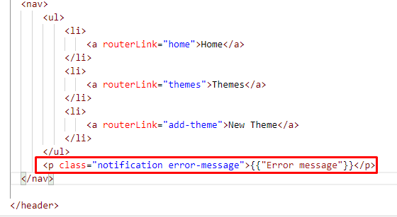

.notification{

  position: fixed;

  z-index: 10;

  right: 8%;

  top: 8%;

  padding: 0.5rem;

  border-radius: 0.5rem;

  color: rgb(255, 255, 255);

  font-style: italic;

  text-decoration: underline;

  box-shadow: 0 5px 10px rgb(204, 204, 204);

  background-color: rgba(238, 74, 74, 0.699);

}

.error-message {

    background-color: rgba(238, 74, 74, 0.699);

}

.success-message {

    background-color: rgba(99, 230, 81, 0.699);

}

## Lazy Loading

Lazy Loading helps us to **download** the web pages **in chunks.** Try to lazy load all the modules you can.

## Pipes

Try to write pipes, as follows:

* Write a pipe for slicing long titles of the themes (25 chars max). You can use the "SlicePipe" provided from Angular or write your own.

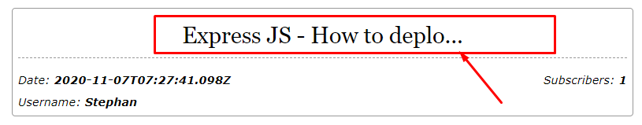

* Write a pipe to convert the date, as shown in the pictures:

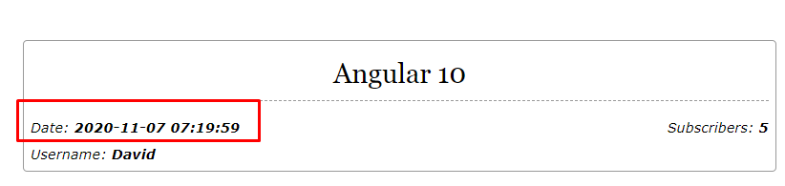

* Write another pipe, which calculates the time since the post is created:

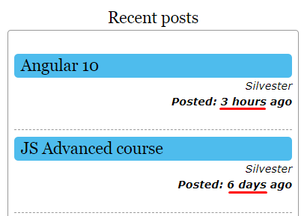

***GOOD LUCK*!**